Hands-On Lab: Class C IP Addressing & Subnetting
This lab uses Class C private IPv4 address space (192.168.1.0/24) so students can perform all binary calculations, subnet boundaries, and host ranges manually within the 4th octet.
Exercise 1: Class C CIDR Prefix Analysis
When subnetting a Class C network (192.168.1.0/24), the first three octets (192.168.1) remain fixed as the network prefix. Subnetting occurs exclusively by borrowing bits from the 4th octet.
Subnetting a Class C Network (192.168.1.0/24)
• Base Network: 192.168.1.0/24 (256 total addresses)
• Design Goal: Divide 192.168.1.0/24 into 4 equal subnets to serve two public web subnets and two private application subnets.
Task 2.1: Complete the Class C Allocation Matrix
Subnet Name | CIDR Block | Network ID | Broadcast ID | Standard Usable IP Range | Cloud Usable IP Range (AWS)
Public Subnet 1 (AZ-A)
Public Subnet 2 (AZ-B)
Private Subnet 1 (AZ-A)
Private Subnet 2 (AZ-B)

Cloud Reserved IPs Requirement
Standard on-premises subnets subtract 2 addresses (Network .0 and Broadcast .255). AWS subnets reserve 5 addresses per subnet (Network .0, Router .1, DNS .2, Reserved .3, Broadcast .255).

Verify via CLI (ipcalc)
Verify your manual 4th-octet calculations using ipcalc:
ipcalc 192.168.1.0/26
Or Use any online IP subnet calculators

Exercise 2: Local Interface Inspection
Task 3.1: Linux / macOS Interface Check
ip -4 addr show
ip route show
Task 3.2: Windows Interface Check (PowerShell)
Get-NetIPAddress -AddressFamily IPv4 | Format-Table IPAddress, PrefixLength, InterfaceAlias

Example 1

CIDR | Calculation | Total addresses
/24 | 2⁽³²⁻²⁴⁾ = 2⁸ | 256
/25 | 2⁽³²⁻²⁵⁾ = 2⁷ | 128
/26 | 2⁽³²⁻²⁶⁾ = 2⁶ | 64
/27 | 2⁽³²⁻²⁷⁾ = 2⁵ | 32
/28 | 2⁽³²⁻²⁸⁾ = 2⁴ | 16

Subnet Name | CIDR Block | Network ID | Broadcast ID | Standard Usable IP Range | Cloud Usable IP Range (AWS)
Public Subnet 1 (AZ-A) | 192.168.1.0/26 | 192.168.1.0 | 192.168.1.63 | 192.168.1.1 – 192.168.1.62 | 192.168.1.4 – 192.168.1.62
Public Subnet 2 (AZ-B) | 192.168.1.64/26 | 192.168.1.64 | 192.168.1.127 | 192.168.1.65 – 192.168.1.126 | 192.168.1.68 – 192.168.1.126
Private Subnet 1 (AZ-A) | 192.168.1.128/26 | 192.168.1.128 | 192.168.1.191 | 192.168.1.129 – 192.168.1.190 | 192.168.1.132 – 192.168.1.190
Private Subnet 2 (AZ-B) | 192.168.1.192/26 | 192.168.1.192 | 192.168.1.255 | 192.168.1.193 – 192.168.1.254 | 192.168.1.196 – 192.168.1.254

R1
_______|_______
/ | \ \
LAN 1 LAN 2 LAN 3 LAN 4
/26 /26 /26 /26

Step 1: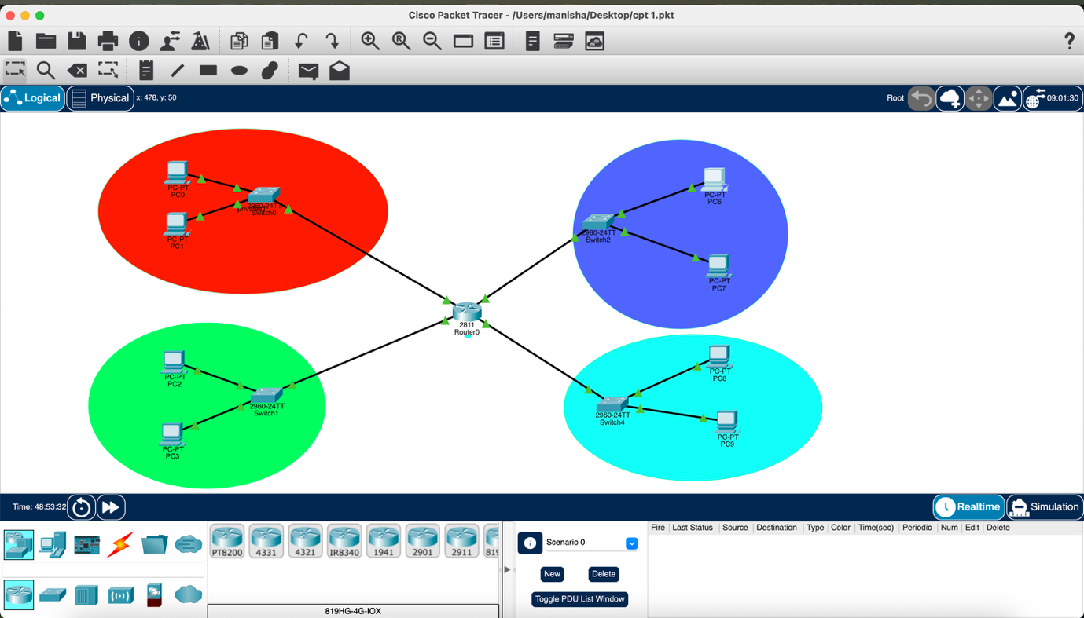

Step 2:
Sample Router IP:
Router 1:  192.168.1.0/26  ↓  Router = 192.168.1.1 | Router 3:  192.168.1.128/26  ↓  Router = 192.168.1.129
Router 2:  192.168.1.64/26  ↓  Router = 192.168.1.65 | Router 4:  192.168.1.192/26  ↓  Router = 192.168.1.193
Keep subnet mask: 255.255.255.192
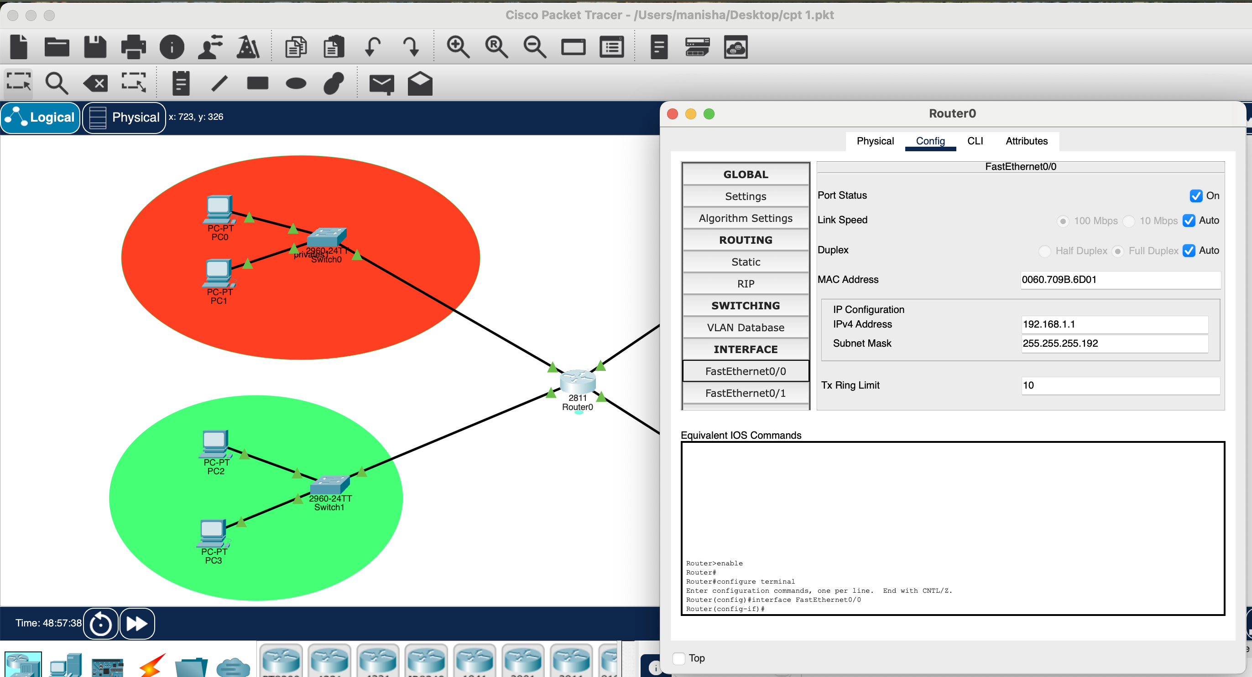
Repeat the steps for all 4 ethernet cables in the router

Step 3:
Subnet 1 red | Subnet 3 blue
PC1:  IP Address: 192.168.1.10  Subnet Mask: 255.255.255.192  Default Gateway:192.168.1.1  PC2:  IP Address: 192.168.1.20  Subnet Mask: 255.255.255.192  Default Gateway:192.168.1.1 | PC5:  IP Address: 192.168.1.132  Subnet Mask: 255.255.255.192  Default Gateway:192.168.1.129  PC6:  IP Address: 192.168.1.133  Subnet Mask: 255.255.255.192  Default Gateway:192.168.1.129
Subnet 2 green | Subnet 4 light blue
PC3:  IP Address: 192.168.1.70  Subnet Mask: 255.255.255.192  Default Gateway:192.168.1.65  PC4:  IP Address: 192.168.1.71  Subnet Mask: 255.255.255.192  Default Gateway:192.168.1.65 | PC7:  IP Address: 192.168.1.200  Subnet Mask: 255.255.255.192  Default Gateway:192.168.1.193  PC8:  IP Address: 192.168.1.205  Subnet Mask: 255.255.255.192  Default Gateway:192.168.1.193

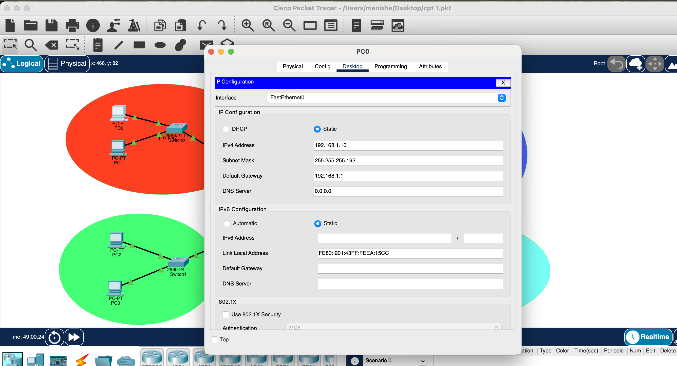

Setup the IP’s of all the PC’s in all the subnet based on the above predefined configuration in table above.
To test the configuration:
From PC1:
Ping 192.168.1.71
